CALLING ALL YEAR 7-9 STUDENTS
EVENT DATE: Wednesday 17th April 2024
Get a basic understanding and elementary insight into some of the most interesting trades within the construction industry.
Ever wondered how buildings are designed and built, or how they’re constructed inside?
What about how the ground is prepared prior to construction work beginnings, or how the area is surveyed?
You can attend a range of exciting and interactive activities that will help you understand how all this happens, and maybe spark your interest into considering a future career in one of the many rewarding opportunities with the diverse industry of construction and demolition.

WORKSHOP EXAMPLES:
House Building  with Lego  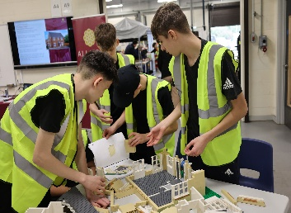 | Joinery  Bird Box  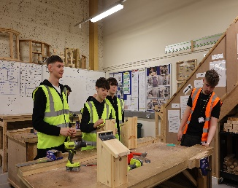 | Cat & Genny  Detection  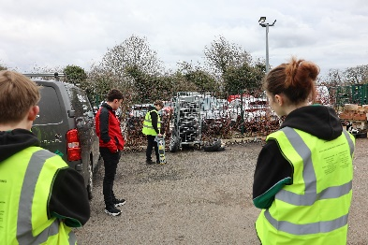 | Plant Training  Diggers  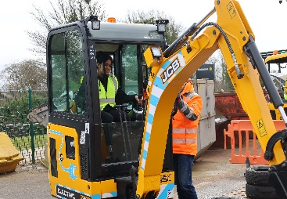
Tetrahedron Building  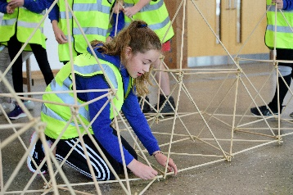 | Scaffolding  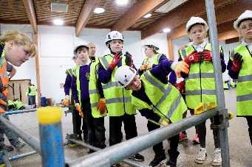 | Brick laying  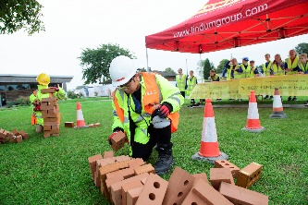 | Painting & Decorating  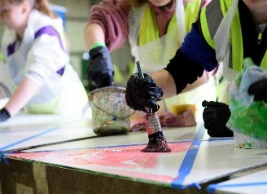
Plumbing  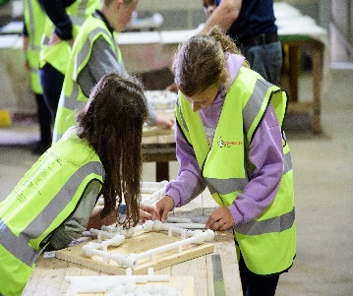 | Demolition Simulator  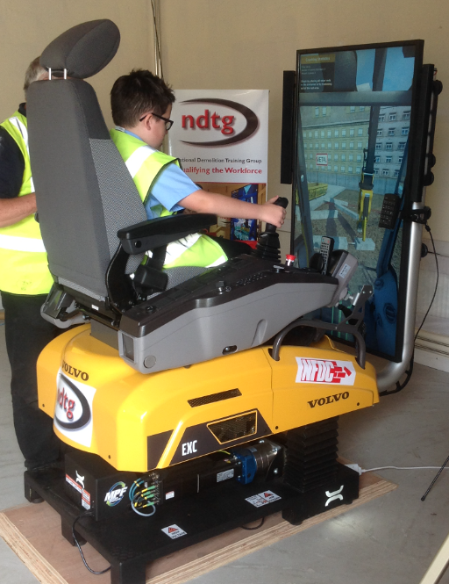 | Surveying   | Drone working  

Students who display a flair in their chosen activity will receive an award upon completion
Construction careers account for more than half of the entire workforce of the UK and are available for both boys and girls.
The vast diversity of career paths within the construction industry can provide continual personal and financial development for everyone involved. Every business owner and multi-millionaire within the construction industry started with a basic understanding at some point in their early life.
Come and experience yours, and have some fun at the same time

EVENT DATE: Wednesday 17th April 2024
HOW IT WORKS
Planned H&S Briefing in Centre Main Hall @ 9.00am (please have one member of staff attend)  - Arrival of schools 9.30am - 9.45am  - Welcome/briefing 9.45am - 9.55am  - Session 1 (10.00am - 10.50am)  - Changeover 10.50am - 10.55am  - Session 2 (10.55am - 11.45am)  - LUNCH 11.50am - 12.20pm  - Session 3 (12.25pm - 1.15pm)  - Changeover 1.15pm - 1.20pm  - Session 4 (1.20pm - 2.10pm)  - Closing 2.15pm - 2.30pm  - Schools Depart 2.30pm | PHOTOGRAPHY  There will be a commissioned photographer for the event and will be available to take any specific images that you would like of your activity / presence at the event.  He will be with the school group staff member will determine whether students can or cannot be included in the image.  The photographer will collate all photos taken and these will be sent out to the head person for each school attending.

For more information about this event please contact Adele Doyle
Action for Construction Training Group
adele@afc-tg.org
www.actionforconstruction.org

